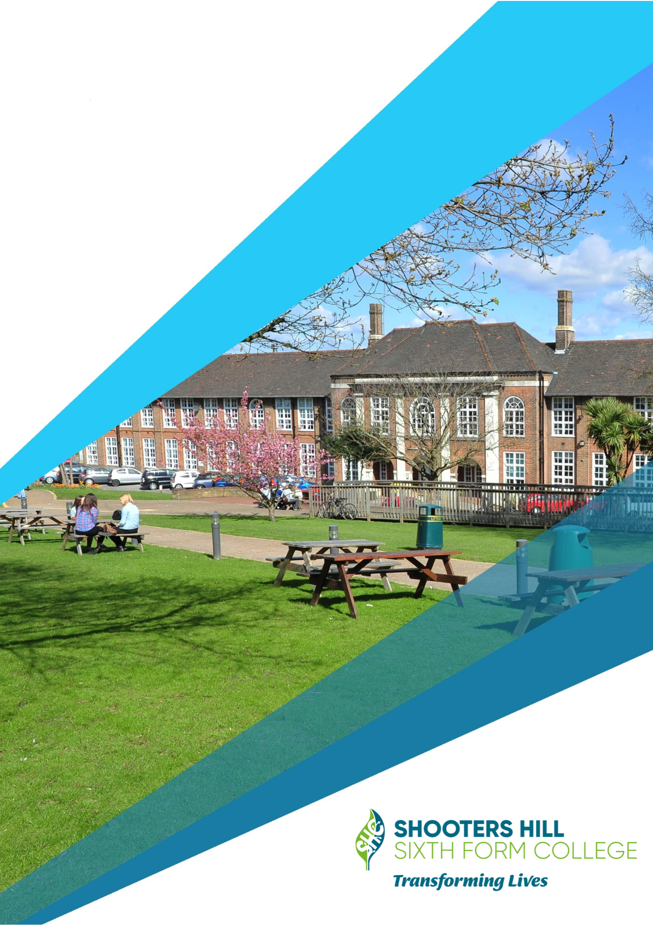
16-19 BURSARY FUND
POLICY 2022-23

Important information for all students and their parents/guardian/carers.
The Bursary fund is made available from the government through the Education and Skills Funding Agency (ESFA) to provide students whose access to, or completion of, education is inhibited by financial constraints or barriers.
Applying for bursary fund WILL NOT affect your existing benefit or household benefits.
Who is eligible?
The student must be aged 16 or over but under 19 on the 31st of August 2022 to be eligible for help in the 2022/23 academic year and a legal resident of the UK or a registered asylum seeker.
There will be four levels of Shooters Hill Sixth Form College’s bursary and you can only apply for ONE:
- Level 1 - Vulnerable Bursary
For those students most in need, such as young people in care, care leavers, young people receiving Income Support (IS) or Universal Credit (UC) in their own right (because they are financially supporting themselves) and disabled young people receiving Disability Living Allowance (DLA) or Personal Independence Payments (PIP) in their own right as well as Employment and Support Allowance (ESA) or Universal Credit in their own right and can apply for a bursary of up to £1,200 per year.

- Level 2 – Discretional Bursary A
This bursary is for students from a non-working household and who are eligible for Free School Meals. This will be payment for specific items up to a maximum of £750 per year, according to need. Amounts paid will be subject to the number of students applying for a Level 2 bursary and the availability of funds. Should entitlement to Free School Meals stop, the Level 2 bursary would also cease and transfer to Level 4.

- £500 to assist you with Uniform, Kit and equipment purchase.
- £250 made up of five (5) maintenance payments of £50 to be paid at the end of each half term (excluding the end of summer term) provided you have met the terms and conditions of the Student Bursary Agreement.

  - Maintenance payments will only be issued if you have achieved 95% overall attendance for each half term. Attendance will be reviewed on the Monday prior to each payment. If you have any authorised absences, you will need to have them authorised before these days. You can authorise your absence through your tutor or through the Student Services department in D Block Level 3.
- Maintenance payments will be withheld if: -
  - If you have less than 95% overall attendance.
  - you have been consistently late to lessons and tutorials.
  - you have been excluded or expelled.
  - you behave inappropriately.
  - if you miss deadlines and targets.

Maintenance payments should be used for costs relating to your education. This could include basic stationery, notebooks, bags & rucksacks, additional course materials not included in the essential equipment list; sports equipment; ad hoc travel or lunch costs; photocopying and printing costs; and appropriate footwear and clothing.

All costs are paid for internally so you must inform me directly if you need funding for any equipment, uniforms or kits.

You can do this via email bursary@shc.ac.uk, in person at Bursary Office or through your tutor. We do not issue refunds for costs you have already paid.

If you are unsure about what equipment you may require for your course, please talk to your tutor and subject teachers and they will be able to advise you.

- Level 3 – Discretional Bursary B
This is for those students with a financial need but who do not fall into the above categories, a bursary fund of up to £400 per year can be available. The criteria are that the total household income must not exceed £30,000 per annum and that no other income is available from another household to support the student. Evidence of income and benefits will be required.

- Level 4 - Students on Free School Meals (FSM)
For any student who has been in receipt of Free School Meals in the last six (6) years. You can apply for a bursary of up to £400 per year. Receipt of previous entitlement will be confirmed by the school with the local authority and/or Department of Education. Subject to household income.
- Emergency Food and Severe Hardship (new for 2022-23)
The Government has asked Colleges to provide food support for students experiencing severe hardship whilst attending their study programmes and courses using the bursary fund during 2022-23 academic year.

In addition, all students eligible for free school meals will continue to get their daily allowance in line with the set government guidance to enable them to purchase food from the College canteen and cafe.
All applications must clearly state the identifiable financial need and provide evidence to support this.
Students that meet the criteria for bursaries are not automatically entitled to a bursary if they do not have a financial need and/or their financial needs are covered from another source.
Parent/Carers may send in confidential information separately to the application form if they wish.
All bursary awards will be dependent on high standards of behaviour, full adherence to the College’s procedures and good attendance (at least 95%). Shooters Hill Sixth Form College reserve the right to withdraw payment where it is deemed the above conditions have been breached, this may be a temporary withdrawal or for the duration of the whole Academic Year 2022-23 according to the severity of the breach.
Bursary payments are made directly to students not to their parents or carers. Payments from Shooters Hill Sixth Form College will be made in arrears by bank transfer to the individual student or be ‘in kind’ for example by purchasing equipment/books or bus passes rather than allocating a cash payment. On occasion, in very exceptional circumstances, College may allow for earlier payment.
What can the money be spent on?
The Bursary fund is intended to help student with essential costs of participating in their study programme, for example, fund can be spent on IT equipment (procured by College), books, course materials, course related trips, meals, transport, clothing or other course related costs needed to help a young person stay in full time education and for Universities open days.
The bursary fund cannot support costs not related to education, extra-curricular and enrichment activities or to provide learning support such as counselling, mentoring or extra tutoring.
Work experience related student costs, transport to/from interview venues, will be funded by the T-level bursary available from Employment and Work Experience team, 3rd Floor, D Block.
What happens to my application form?
Shooters Hill Sixth Form College Bursary Panel comprises of the Director of Finance, Finance Manager and Bursary Officer. The Panel will sit in each term to assess each claim and authorise payments during:
- September.
- January.
- April.
Payments will be made to successful students after the Panel have considered their applications. Applications approved will be monitored and grant may be withdrawn at any time a student fails to meet the criteria and conditions set out above.

